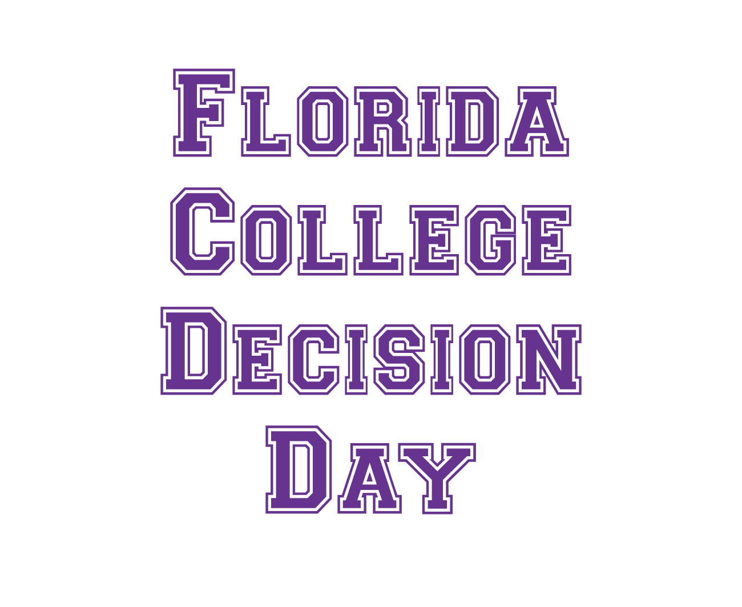

Site Coordinator   
Resource Manual

May 2015

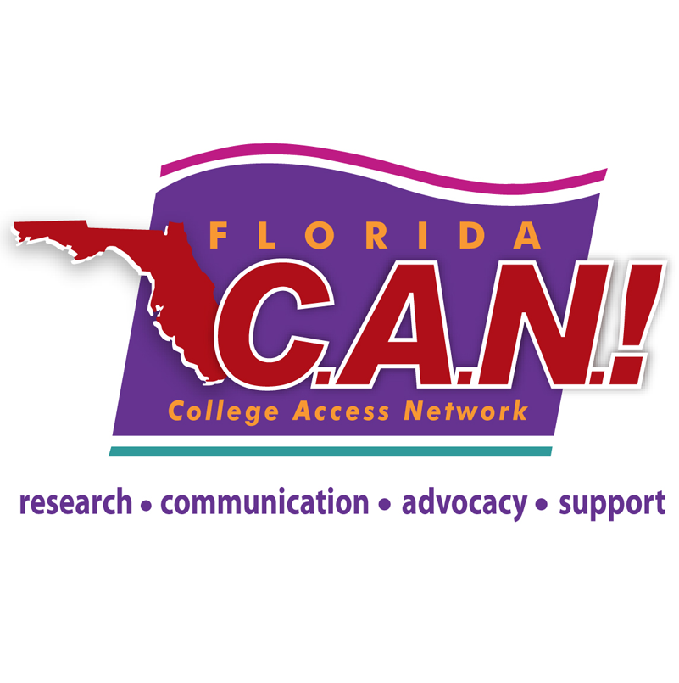

# Table of Contents

Section I - Introduction 2

Welcome Letter ………………………………………………………………………………………………………………………………………….2

About the Florida College Access Network 3

What’s in a name? Understanding the word ‘College’ 4

About College Decision Day 5

Section II - Ideas For Your event 6

Ideas for Celebrating Decision Day 6

Promoting College Decision Day in the Community 8

Examples from Michigan High Schools 9

Section III - Planning Your Event 10

Site Coordinator Checklist 10

Budget 12

Section IV - Preparing Students 13

Senior Checklist: Common Enrollment Steps 13

Next Steps for Students Who Haven’t Officially Enrolled in College 14

Section V - Engaging Families 15

Student/Family Informative Letter 15

Student/Family Follow-up Letter 16

Acknowledgements 18

Section I - Introduction

Dear Decision Day Site Coordinator:

On behalf of the Florida College Access Network (FCAN), thank you for deciding to host a College Decision Day event on or around May 1, 2015, at your school!

The goal of Florida College Decision Day is to recognize and celebrate seniors for their postsecondary plans and encourage younger students and their families to prepare early for college. It is important that we celebrate this big step for seniors, and involving all of your students will help build a college-going culture at your school. College Decision Day is held annually on or around May 1 and is designed to coincide with the date that most seniors must inform a college of their plans to attend.

College Decision Day is a new statewide initiative in Florida, based on similar, highly successful initiatives by the City of San Antonio, Texas, and the Michigan College Access Network. While many schools in Florida have individually decided to recognize college-going students, this initiative aims to bring statewide attention to the importance of this kind of recognition. Additionally, it aims to provide resources that will make the adoption of College Decision Day quick and easy for schools.

To help you prepare for College Decision Day, we are pleased to provide this planning guide, as well as the following supplemental guides:

1. Creating a College-Going Culture
2. Media Outreach
3. Volunteer Management
4. Business Outreach

Please feel free to contact Arianna Pineiro, FCAN’s Special Projects Coordinator, at (813) 974-6429 or email [apineiro@floridacollegeaccess.org](mailto:apineiro@floridacollegeaccess.org) if you have any questions or concerns about planning and implementing the event at your school. We will be sure to keep you updated regarding any changes or additional information you may find useful.

We thank you for helping to drive this initiative. We hope that this is the start of a tradition that will continue across Florida for years to come, encouraging Florida students and their families to make college part of their futures!

Sincerely,

The FCAN Team

# About the Florida College Access Network

Florida College Access Network is a statewide network of leaders, organization, educators, and individuals who are collectively committed to dramatically increasing postsecondary opportunities for all Florida students—especially students traditionally underrepresented in higher education, such as low income students and those who are the first in their families to go to college.

**Our Mission:** To create and strengthen a statewide network that catalyzes and supports communities to improve college and career readiness, access, and completion for all students.

**Our Vision:** At least 60% of working-age Floridians will hold a high-quality post-secondary degree or credential by the year 2025.

**Our Guiding Values:**

* College is postsecondary education.
* College readiness is career readiness.
* College is for everyone.
* College is a public good.
* Achieving Goal 2025 will require collective action.

# What’s in a name? Understanding the word ‘College’

College is important – there’s no doubt about it. Unlike past generations, today’s students need a postsecondary degree or credential to earn a middle class income. Labor economists project that by 2020, 65% of jobs in Florida will require a postsecondary education.[1] Yet Florida’s attainment rate for a two year degree or higher is currently about 38%—ranking the state at 30th in the nation.[2] For our students to be successful in the 21st century workforce, it is essential that they plan to complete some type of education beyond high school.

Florida College Access Network uses the word “college” to include any type of high-quality postsecondary education or training beyond high school—including two- and four-year degrees as well as credentials (such as industry-recognized certifications) that qualify students for gainful employment and/or opportunities to pursue additional training or education. That means students have many options when it comes to attending college. College Decision Day recognizes and celebrates all of these paths.

# About College Decision Day

#### What is Florida’s College Decision Day?

The goal of Florida’s College Decision Day is to recognize high school seniors for their postsecondary plans and encourage younger students and families to prepare early for postsecondary education. College Decision Day is held annually on or around May 1 and is designed to coincide with the date that most seniors must inform a college of their plans to enroll.

College Decision Day is inspired by the NCAA’s National Signing Day to reinforce that excellence in the classroom should be given as much pomp and circumstance as excellence in athletics. NCAA’s National Signing Day is when high school seniors sign a letter of intent to play sports at a specific college. Traditionally, student-athletes participate in press conferences to announce their intent to attend a college. Our goal is to mimic this excitement for ALL students going to college regardless of their participation in a sport.

Florida’s College Decision Day is a new statewide initiative. Up until now, many schools have individually found ways to recognize students for their postsecondary plans. However, the initiative has never had statewide attention or the resources available for Florida high schools to quickly and easily adopt.

#### Why Host College Decision Day?

* To recognize all students for their postsecondary plans
* To encourage and remind students that it’s time to make a decision
* To support the best match and fit for each student
* To influence younger students as they prepare for college
* To support a college-going culture and wrap up the school year with a celebration

#### Expectations of Host Sites

While each school must decide for itself the best way to celebrate College Decision Day, we encourage host sites to create an event that, at a minimum, follows these guidelines:

* Recognize ALL students for their postsecondary plans (2-yr, 4-yr, military, postsecondary certificate)
* Hold recognition in front of the high school’s entire student body
* Contact local media – encourage publicity beyond the high school community
* Have fun!

SECTION II –

Ideas for your event

# Ideas for Celebrating College Decision Day

College Decision Day will look different at each high school. It is important to plan an event that fits the needs of your students and community. During the planning and implementation stages of your College Decision Day event, it is very important to keep your school staff apprised of the event schedule. Work with members of your school’s staff to identify the most effective schedule possible for your specific high school.

**Celebrate your seniors and their families, and acknowledge their decision to enroll in college.**

* *Create a “College Wall.”* Seniors write the names of the college where they plan to attend on banners or strips of construction paper to hang in a main hallway. Utilize art teachers (if available) for additional promotional materials to create a “college-going culture” on the walls of your school.
* *Announcements*. Make announcements over the school audio/video system to acknowledge students who decided to enroll and share where they will be going to college.
* *Assembly.* Host an all-school assembly to celebrate the postsecondary accomplishments of each of your seniors and their families. This event assembly could be an add-on to an already established school event or a stand-alone assembly. Make sure to invite students of all grade levels to participate.
  + *Consider giving prizes or “SWAG”:* Ideas might include a microwave, mini-fridge, tablet, computer, college survival kit, pencils, flags, t-shirts
  + *Serve cake or cupcakes* or other refreshments
* *Community Picnic or Fair.* Host an afterschool community-wide picnic or celebration. This may require a larger budget, but will involve more community members and students of all ages.
  + *Food:* Pizza and BBQ are always a hit.
  + *Entertainment:* Consider a DJ or local band, plan a flash mob, or provide games for all ages.
* *Guest speakers.* Whether you host a school assembly or a community event, invite high school alumni, elected officials, college admissions and financial aid representatives, local business leaders and parents to congratulate the students on their decision to go to college and to emphasize, from personal experience, the importance of college.
* *Interviews.* Interview seniors about their college plans and write articles for local newspapers and the school newspaper. Incorporate quotes from seniors in public service announcements for local radio, intercom/homeroom announcements, or ads in the school newspaper. Or, create a special section in the school newspaper that gives the names of seniors and their selected college.
* *College gear.* Encourage students and school staff to wear college t-shirts on the day of your event and/or a particular day of the week.
* *Social media*. As students bring in evidence of their postsecondary plans in the form of a college acceptance letter, military orders, or a similar offer letter, take pictures of the students with those letters/forms and post it through the school’s social media channels using the hashtags #ImGoingToCollege, #CollegeDecisionDay, and #ReachHigher.
* *Involve teachers and staff*. During College Decision Day, ask teachers to share their college experience, wear their alma mater gear and post signs on classroom doors showing where they went to college. Promote the idea of college, not a specific school.

**Provide early awareness of the steps needed to enroll in college for younger students and families.**

* *Workshops.* Provide workshops to younger students and their families.
  + Possible topics: decision making, learning styles, study habits, the importance of GPA and high school course selection, college test prep, how to get help with grades and test prep, essay writing, applying to college, college admission criteria, paying for college, “I’m admitted – now what?”, etc.
* *College spotlight*. In the months or weeks leading up to College Decision Day, choose a different college or university to feature in each morning’s announcements. Play the school’s fight song. Ask trivia questions and award prizes for correct answers.
* *Adopt-a-College.* Each classroom can “adopt” a college to represent for the rest of year. This can be the teacher’s alma mater or the class may select a college/university. Students can decorate the classroom door with the college/university colors and logo.

**Conduct one-on-one or classroom visits with seniors and ask students if they have:**

* Applied to college?
* Been admitted to college?
* Officially notified the college or university that they will enroll?
* Completed the FAFSA?

**Gather students’ college choices in advance. Some schools require seniors to bring evidence of their postsecondary plans in the form of a college acceptance letter, military orders, or similar offer letter.**

* *Day of event:* The simplest and quickest way to ensure you have the college decision for each student is by handing the student a blank note card a few minutes before the event begins. Ask each student to write down their name and selected college. This method is sometimes used during graduation ceremonies.
* *Week(s) prior to event:* Survey the seniors or schedule one-on-one visits. Ask the seniors to provide basic information of where they plan to go to college, where they are in the enrollment process, questions they have, and how you can assist them.

# Promoting College Decision Day in the Community

The following are recommendations for promoting your College Decision Day event.

* *Form a planning committee* to decide on the options and brainstorm additional activities, then make assignments and deadlines. This committee may include different groups such as faculty, staff, families, student groups, college representatives, and community members.
* *Set goals* for the number of seniors enrolling, number of younger students engaged, number of volunteers, etc. Remind everyone of these goals and the importance of reaching as many people as possible in order to promote a college-going culture in your school community.
* *Hold special meetings or workshops* such as a College Alumni Parent Night and “Ask Me About It!” (see details included in Supplement A: Creating a College-Going Culture) as opportunities to help students make a decision that is the best match and fit prior to College Decision Day.
* *Hold one or more “Senior Meetings”* with school staff to facilitate communicating high expectations regarding College Decision Day activities to students. Often, principals hold these types of meetings to communicate information.
* *Send email or text reminders* to all parents, students, and school staff in addition to the official Student/Family letter. Also, *include information in the school newsletter and post fliers* around the school and community about your College Decision Day event.
* *Media.* Write and send a press release inviting local media to your event(s). Make sure to also send your press release to FCAN, too! For additional information and guidance, see Supplement B: Media Outreach.
* *Recruit volunteers from students’ families and community organizations.* Be creative! Send a version of the attached form volunteer letter to your Local College Access Network, volunteer groups, Boys and Girls Club, YMCA, church groups, city and county government, local businesses, etc. Your Local College Access Network will be able to help you establish a point of contact.

# Examples from Michigan High Schools

Looking for more ideas? Here are a few descriptions of College Decision Day events by organizersof past events in Michigan high schools:

Example #1:   
“We hold a College Signing Day that highlights academic scholars who have been accepted to college. We mimic the NCAA model with purpose to reinforce that excellence in the classroom should be given as much (if not more) pomp and circumstance as excellence on the field, court, etc. We host a school wide assembly, usually before lunch, where all students witness our seniors commit and physically sign a statement of intent to enroll, accompanied by admissions representatives from their respective schools. I'd even go so far to say it ROCKS.  We also celebrate ALL seniors during a morning assembly once every kid has received an admission letter. We play a slide show of EVERY school that accepted our students and allow kids to wear sweatshirts/tees with the college of their choice over their school uniform. Since many of our students rely on financial aid to actually accept offers, we try to not push the kids to advertise where they are going since their dream school may not fund them and pushing them to recognize this fact hurts more the helps our mission.”

Example #2:  
“We did this for the first time last year and loved it.  We wanted to honor every senior's postsecondary plans whether they included 2-year, 4-year, military or certificate so we called it Postsecondary Celebration Day and held our event on 5/1. We kept it casual and had a quick morning event. We invited all seniors, their parents, underclassmen, and faculty to mingle in the cafeteria at 7:15 am to 7:45 am. We wanted parents to be able to stop in on their way to work. Students and faculty were instructed to wear college t-shirts. We had each senior picture hung up with their name and their plans. The PTO donated simple breakfast items such as coffee, juice, water, and muffins. We played college fight songs in the background. At about 7:30 our principal made a few quick remarks about how proud we are of our seniors and their wonderful plans, etc. It was a great day!”

Example #3:

“On May 1st or the closest to May 1st as possible, we do a senior signing where seniors wear the t-shirt/sweatshirt of the college they will be matriculating to. The faculty and staff also wear college gear of their choice. The seniors go to an area where they meet their counselor and sign a pennant with their name and the name of the college, career or post educational option.  We take pictures and tweet them out and hang all of the pennants on the outside windows of our college center.”

Section IIi -

Planning Your Event

# Site Coordinator Checklist

This is a recommended planning process and timeline that utilizes the recommendations found throughout this Resource Guide. You are welcome to adjust dates to fit your school best. Ultimately, your College Decision Day event will depend on the available budget and time. It is our hope this Resource Guide will save you some of that time and cost! Remember, the earlier you are able to complete these tasks the better.

|  |  |  |
| --- | --- | --- |
| WEEKS BEFORE EVENT | DATES | TASKS |
| 8-7 |  | * Set up a College Decision Day committee or team at your school to discuss the timeline and event (school counselors, teachers, administrators, students, parents/guardians, higher education admissions/outreach staff, LCAN representative, etc.) * Evaluate resources and budget for event * Brainstorm possible speakers to invite, agenda for the event |
| 6 |  | * Confirm event location, date and time. * Share information with school administration, teachers and staff. * Discuss possible tie-in assignments with teachers * Share final plans with FCAN using provided form. * Share plans with LCAN (if applicable). |
| 5 |  | * Invite potential guest speakers * Reach out to local businesses and colleges asking for donations and sponsorships * If providing food, reach out to restaurant/catering company |
| 4 |  | * Provide seniors with enrollment checklist (see p. 13) * If necessary, begin volunteer outreach * Plan and prepare outreach and publicity efforts: Develop a press release to send local newspapers and TV stations (template provided), and brainstorm locations to hang fliers outside of the high school |
| 3 |  | * Send students and parents letter to notify them of the activities, encourage parents to come (optional), info about financial aid, reminder that it's not too late for college (see pg. 14) * Make robocalls or text message alerts to parents (if school already has system in place) * Use any social media presence the school has. * Add information about event to daily announcements, school website/newspaper/newsletter, marquee, atc |
| 2 |  | * Finalize speakers and agenda for event * Distribute press release to media * Finalize volunteer list * Buy necessary (non-perishable) supplies * Confirm any additional personnel needed (custodial staff, etc) * Wrap up senior meetings, going over expecations of the event, and confirming college plans with each of the students |
| 1 |  | * Remind teachers, counselors, administrators of the day’s schedule and planned activities. Encourage them to wear college clothing on the day and decorate their classrooms. * Make sure all event supplies are ready, pick up food (if applicable) * Distribute media advisory day of/day before event; follow up with media contacted earlier to confirm if they will attend |
| DAY OF EVENT |  | * Set up venue. * Take pictures and upload them to Facebook, Twitter, Instagram, etc. using the hashtag #ImGoingToCollege, #CollegeDecisionDay, and #ReachHigher |
| AFTER  EVENT |  | * Send follow up letter to students who participated and their families (see p. 15). Congratulate them on being one step closer. Remind them of steps to take this summer. * Send thank you letters to volunteers, school administration, catering, businesses, colleges and universities, and guest speaker(s). * Submit event summary via survey to be provided by FCAN. Share any photos. |

# Budget

In the early stages of planning, we recommend that you determine your school’s budget for this event, as well as a list of supplies and services you will need to execute the event. While it is up to each school to figure out what works best for them, College Decision Day does not require a large budget. Even if your school is interested in providing food or prizes, many businesses are willing to donate supplies. For more information on outreach to local businesses, see Supplement D: Business Outreach.

**Funding from High School:** $

**Other Sources of Funding/In-Kind Donations:**

|  |  |  |  |  |
| --- | --- | --- | --- | --- |
| Item/Service | Purchased/ Donated | Anticipated Cost | Actual  Cost | Notes |
|  |  |  |  |  |
|  |  |  |  |  |
|  |  |  |  |  |
|  |  |  |  |  |
|  |  |  |  |  |
|  |  |  |  |  |
|  |  |  |  |  |
|  |  |  |  |  |
|  |  |  |  |  |

Section iV –

PREparing Students

# Senior Checklist Common Enrollment Steps

Colleges and universities require students to officially enroll in college, typically on or before May 1st. Here are common enrollment steps, but be sure to check the college or university’s official website and correspondence for specific and up-to-date information.

* Talk to your family, teachers, counselors, college advisers, college outreach program staff, and people you trust to help you make your decision about where to enroll.
* If you’ve applied for financial aid by completing a FAFSA, read and understand your Student Aid Report (SAR) to find out how much financial aid you have received. If you have questions, be sure to share them with your college’s financial aid office.
* To enroll, follow the directions in the official acceptance letter/email you received from your college. Each college has its own steps and system for officially enrolling. Most likely, you will be directed to the college’s official website and instructed to log into the internal student information system. If you need help, don’t hesitate to ask questions of your college.
* Some colleges require a monetary deposit to officially enroll. This deposit can range from $100 to $500 or more. If you need help, don’t hesitate to contact the college’s financial aid office to discuss options.
* As part of the enrollment process, you may be prompted by the college to sign up for a campus email, campus housing, accept your financial aid award, and/or start the advising process to sign up for classes.
* After you have officially enrolled, you will also get information from your college about summer orientation and placement exams. Be sure to sign up for any required testing and attend orientation events.
* After you have officially enrolled, make sure to request a copy of your final high school transcript to be sent to your college.
* Check out your college’s summer reading list to get a jump start on your college experience.
* Don’t melt this summer! “Melting” means you have followed all the steps to officially enroll in college, but for some reason, you don’t show up in the fall. To keep you from melting, here are some tips:

1. Stay active this summer through jobs, internships, clubs, sports, etc.
2. Talk about your college dreams, plans, and fears to your friends, family, and people you trust.
3. Figure out how you will physically get to college in the fall, and ask for help if you need it.
4. Help your family prepare for your college experience – this isn’t just a life change for you, but also for them.

# Next Steps for StudentsWho

# Haven’t Officially Enrolled in College

# **Scenario 1:** Student has not yet applied to college or may have an incomplete application

1. Direct student to Florida Virtual Campus (www.flvc.org) to explore postsecondary options and financial aid information.
2. Connect student with a community college application or a four year university that has a late application deadline.
3. If application(s) are not complete, follow up with the official letter/email from the university to see what exactly is needed to complete the application. Reach out to the college directly to have a conversation.

**Scenario 2:** Student applied to college, but has not yet been admitted

1. Direct student to Florida Virtual Campus (www.flvc.org) to explore other postsecondary options and financial aid information.
2. Connect student with a community college.

**Scenario 3:** Student has been admitted to college, but has not yet decided or officially enrolled

1. Encourage student to talk to trusted adults and share feelings, questions and concerns.
2. Connect student with an admissions officer, financial aid representative, or other expert at the college.
3. Research the college’s steps to enroll and assist student in completing all that are required.
4. Assist student in connecting with financial aid assistance (particularly for help paying enrollment fees and deposits).
5. Help student complete a FAFSA and/or interpret any financial aid information that is received – ask the campus financial aid officer for help.

SECTION V –

Engaging Families

Use these letters to strike up conversations between students and their families about College Decision Day, to recruit volunteers, and inform the school community of activities to promote a college going culture in your school. Disseminate via hard copy and /or email. You can also send out automated phone messages and use whatever other channels of communication your school has available.

# Student/Family Informational Letter

SCHOOL LOGO

SCHOOL ADDRESS

[date]

Dear Students and Families, [change this based on who you’re sending letter to]

The administration and staff of [high school name] invites you to attend College Decision Day on [date] from [time] to celebrate the Senior Class of 2015 as they make the decision on their next steps after high school.

May 1st is a big day across the state and nation in the college admissions process. It’s the day by which seniors nationwide declare what they want to do with their futures and decide where they will go after high school. [School name] will host its [inaugural, 3rd annual, etc.] Decision Day to celebrate the Senior Class of 2015 as they make this important decision to achieve greatness by attending college, trade school or enlisting into the armed services.This celebration also applauds the college-going culture within [school name] as well as within [community name].

[*Insert information about all activities leading up to and during College Decision Day. Include speakers, games, prizes, food, etc. Parking information and/or visitor pass if necessary*]

All graduating seniors are expected to attend and are encouraged to wear a t-shirt of their college selection.

Parents, school administrators, teachers, staff and community members are invited to join the celebration. To RSVP, [insert information]

We are extremely proud of our Senior Class of 2015 and hope you will join us in celebration. We look forward to seeing you on [date].

Sincerely,

[SCHOOL COUNSELOR/PRINCIPAL/SITE COORDINATOR]

# Student / Family Follow-up Letter

SCHOOL LOGO

SCHOOL ADDRESS

[date]

Dear Students and Families,

Recently, your student participated in Florida’s College Decision Day hosted by [high school name]. Congratulations on taking this important step toward your student’s education!

Now that your student has enrolled in a college, it is important that students consider the following next steps:

If you’ve applied for financial aid by completing a FAFSA, read and understand your Student Aid Report (SAR) to find out how much financial aid you have received. If you have questions, be sure to share them with your college’s financial aid office.

To enroll, follow the directions in the official acceptance letter/email you received from your college. Each college has its own steps and system for officially enrolling. Most likely, you will be directed to the college’s official website and instructed to log into the internal student information system. If you need help, don’t hesitate to ask questions of your college.

Some colleges require a monetary deposit to officially enroll. This deposit can range from $100 to $500 or more. If you need help, don’t hesitate to contact the college’s financial aid office to discuss options.

As part of the enrollment process, you will likely be prompted by the college to sign up for campus housing, accept your financial aid award, and start the advising process to sign up for classes.

After you have officially enrolled, you will also get information from your college about summer orientation and placement exams. Be sure to sign up for any required testing and attend orientation events.

After you have officially enrolled, make sure to request a copy of your final high school transcript to be sent to your college.

Check out your college’s summer reading list to get a jump start on your college experience.

Don’t melt this summer! “Melting” means you have followed all the steps to officially enroll in college, but for some reason, you don’t show up in the fall. To keep you from melting, here are some tips:

1. Stay active this summer through jobs, internships, clubs, sports, etc.
2. Talk about your college dreams, plans, and fears to your friends, family, and people you trust.
3. Figure out how you will physically get to college in the fall, and ask for help if you need it.
4. Help your family prepare for your college experience – this isn’t just a life change for you, but also for them.

If you have any questions, please call [name, title], at [phone number] or email me at [email]. Thank you for supporting your student’s future and helping them navigate the path to college!

Sincerely,

[SCHOOL COUNSELOR/PRINCIPAL/SITE COORDINATOR]

Acknowledgements

# This guide is adapted from a toolkit originally produced by the Michigan College Access Network (MCAN). A special thanks to MCAN for permission to adapt this guide for use in Florida, as well as their guidance on the process. FCAN also would like to thank the Helios Education Foundation and the Univeristy of South Florida, whose support made this project possible.

# --------

# Thank you for hosting

# College Decision Day!

1. Carnevale, Anthony, Nicole Smith and Jeff Strohl, “Recovery: Job Growth and Education Requirements through 2020,” Georgetown University Center on Education and the Workforce, June 2013
2. View educational attainment data at the state and county level since 2000 by visiting, The Big Goal: Degree Attainment in Florida, an interactive data dashboard maintainted by the Florida College Access Network: <http://tabsoft.co/1AyVuLa>